Memo **Date: August 15, 2014 page 1 of 2**

To: Francine Locke, Director, OEMS From: Jerry Roseman M.Sc.I.H. President, OHCS, Inc. & Director of Environmental Science and Occupational Health & Safety for the PFT H&W Fund/Union

Re: IEQ Evaluation at Austin Meehan M.S. **Inspection** Date: August 13, 2014

**_________________________________________________________________________________________**

**1.0 Background**

On Wednesday 8/13/14 Brian Joseph and I conducted a joint IEQ-related site visit at the Austin Meehan M.S. The assessment was performed subsequent to:

[1] ongoing concerns and questions received by PFTH&WF/U-H&S/OHCS about the repetitive history of mold, moisture, leaks and air quality deficiencies at Austin Meehan M.S.; and

[2] as a follow-up to the multi-year history of IEQ-related problems at this location.

Austin Meehan M.S. has been the subject of dozens of on-site evaluations over the past 3-4 + years primarily because of the ongoing and serious nature of the problems detected. Unfortunately, and as confirmed during our partial inspection of building areas conducted on 8/13/14, continuing and major problems are still present at this school.

Our inspection on 8/13/14 was of a preliminary and limited nature and we were only able to observe a small % of the school area and rooms. The evaluation and current problem summary provided below therefore presents a necessarily incomplete assessment of all of this school’s potential IEQ-building condition and H&S related problems.

In order to generate a comprehensive and representative picture of all relevant health and safety, and related issues, a joint review and consideration should be immediately conducted to include any/all existing relevant data, reports, recommendations, and documentation from Brian J. [OEMS], FMS and CPO representatives who are responsible for responding to, and correcting damaged and deficient systems and conditions.  Additionally, follow-up evaluation[s] – sometime after the start of school - should be jointly performed to include the inspection of more building areas in addition to gathering additional relevant information from school staff.

**2.0 Issue/Problem Summary**

1. The 08082014 IEQ Dashboard documents a total of 66 IEQ and related deficiencies identified during multiple evaluation and assessments. According to the IEQ Dashboard 52 items were considered as “closed” [79%] and 14 [21%] are still “open” Dashboard items some stretching back 3 years [please note, however, that it is my belief that a number of the “open” items have in fact been “closed”]. At the same time, at least some of the items listed as “closed” were not confirmed as such during our visit;

2. The IEQ Dashboard also lists a total of 18 [27%] “repeat” deficiencies;

3. The IEQ Dashboard entries for this school do not include specific information about prioritization of any of the recommended response actions nor any time frames provided to direct recommendation implementation starting and/or completion dates;

4. Severe continuing and/or repeat water damaged was observed in multiple areas including: [a] basement hallways [“House” B] outside of the gym [across from the Mechanical Room – 5C & across from the School Store], [b] Ground floor Women’s Staff bathroom; [c] the school library – more than one area; and [d] the auditorium lobby – more than one area. Visible mold growth was also observed in the Auditorium Lobby area leading to the main entrance;

5. Active leaking from multiple sources – including but not limited to, windows, HVAC system components and, possibly, roofing systems – was noted;

6. The carpeting in the school library – reportedly currently unused because of the physical condition of the space – is extensively stained and dirty and, along the window wall, was wet to the touch;

7. The significantly deteriorated conditions in the school library are clearly a repeat problem in some areas [at least along the main/lower window wall] and may have never been remediated [upper window related damage] in other areas. In either case, the conditions in the library reflect an inadequate response and remediation effort at this location, resulting in continuing unsafe and unhealthful conditions to occupants and compromising fiscally sustainable practice;

8. The observations in the auditorium lobby are considered to be repeat and/or ongoing deficiencies – similar to the situation observed in the library resulting in continuing unsafe and unhealthful conditions to occupants and compromising fiscally sustainable practice;

9. The conditions in the basement hallway areas as discussed/described herein are also considered to be repeat and/or ongoing problems resulting in continuing unsafe and unhealthful conditions to occupants and compromising fiscally sustainable practice; and

10. The conditions observed and documented at Austin Meehan M.S. on 8/13/14 should not be considered as surprising or unpredictable given the limitations in PSD FMS and/or CPO response and remediation activities nor are these conditions limited solely to Austin Meehan M.S.; instead they represent and highlight system-wide problems.

*\*\* Please note that the summary above should not be considered as a fully comprehensive listing of all problems.*

**3.0 Preliminary Recommendations**

Given the above PFTH&WF/Union-H&S/OHCS is providing the following informational request[s] and preliminary recommendations/action items:

**Action Item 1** - Promptly [prior to 9/2014] assess and repair all leaks [including from, but not limited to, windows, HVAC system components and roofing] and repair and replace all water damaged and stained ceilings, walls and other impacted building materials. Ensure that ***at a minimum*** all listed deficiencies on the PSD-OEMS IEQ Dashboards are addressed and all recommended items are implemented;

**Action Item 2** - Promptly [prior to 9/2014] arrange and/or begin to conduct a systematic and comprehensive review of all building envelope and HVAC system design, operational and related deficiencies, using information included on, and accessible from, IEQ Dashboards, FMS Work Order system information, data and experience of the FACs and B.Es and any other relevant evaluations, assessments and actions conducted to date [include CPO and design information].

This activity should be coordinated and conducted jointly with PFTH&WF/Union-H&S/OHCS representatives and a written detailed informational summary report to be developed and shared with all stakeholders and occupants including PFTH&WF/Union-H&S-OHCS representatives. This report should identify all currently existing problems including “root cause” issues and specific remedial recommendations and implementation time frames should be clearly presented;

**Action Item 3** - Immediately arrange to start a “Tailored Environmental Intervention” [TEI] and an "Environmental Action Team” [E.A.T.] approach as jointly discussed, developed and previously employed by PSD-OEMS at Webster, Lowell, Lawton, as well as at some other locations.  To facilitate effective and open communication and to ensure coordinated and efficient action, the E.A.T. should be composed of a working committee, to include but not be limited to, representatives from PSD OEMS, FMS, CPO, school Principal, occupants and PFTH&WF/Union-H&S-OHCS representatives;

**Action Item 4** – The issues, deficiencies and concerns identified during the evaluation[s] conducted at Austin Meehan, particularly in the context of data collection, IEQ Dashboard/DDC information review, the pressing need to connect and efficiently use data/information from OEMS, FMS & CPO [IEQ Dashboards, Work Order System info and much else], as well as recommendation implementation, should be critically and comprehensively examined by a working committee, to include but not be limited to, representatives from PSD OEMS, FMS, CPO, school Principal, occupants and PFTH&WF/Union-H&S-OHCS representatives, in order to develop an action plan to improve school conditions

**4.0 Representative Photos**

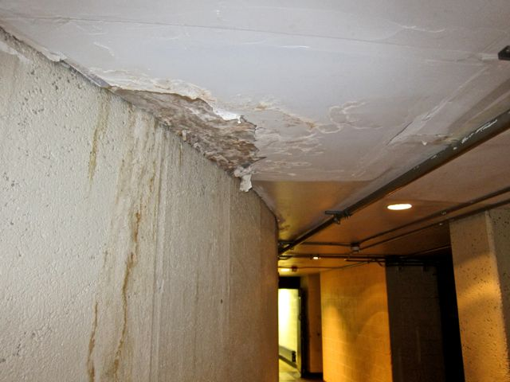

Photo # 1 – Austin Meehan M.S. – 8/13/14 – Ground Floor – House B – Hallway Across from Gym & 5C Mechanical Room

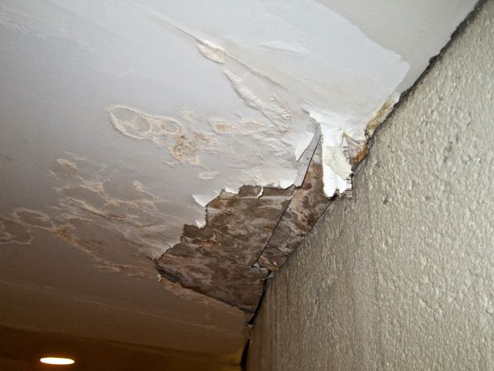

Photo # 2 – Austin Meehan M.S. – 8/13/14 – Ground Floor – House B – Hallway Across from Gym & 5C Mechanical Room – Close up of Damage

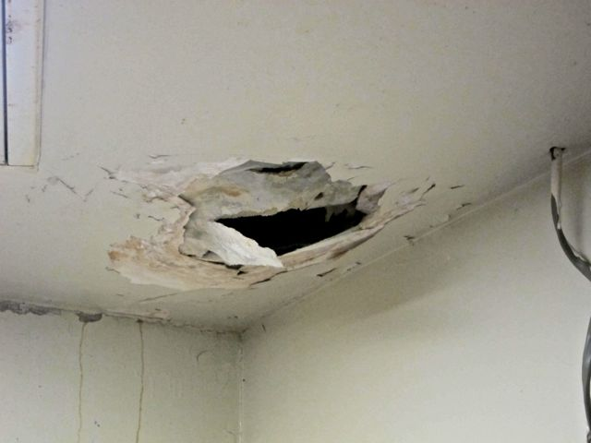

Photo # 3 – Austin Meehan M.S. – 8/13/14 – Ground Floor – House B – Women’s Staff Bathroom – Ceiling Damage

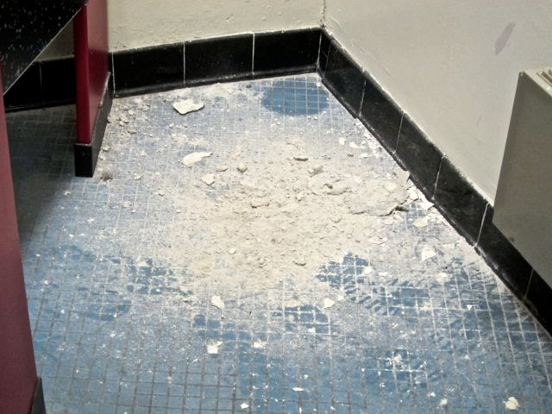

Photo # 4 – Austin Meehan M.S. – 8/13/14 – Ground Floor – House B – Women’s Staff Bathroom – Floor Debris

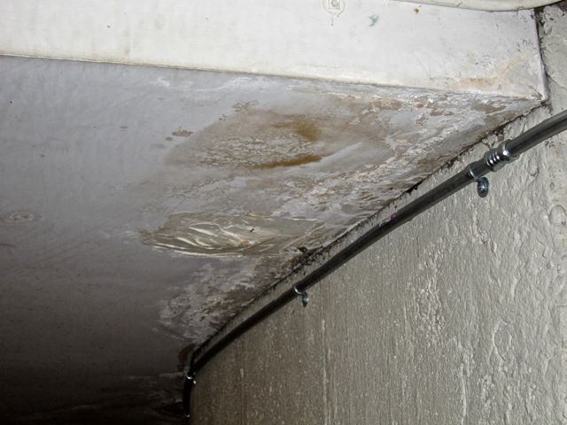

Photo # 5 – Austin Meehan M.S. – 8/13/14 – Ground Floor Hallway Across from Gym & School Store

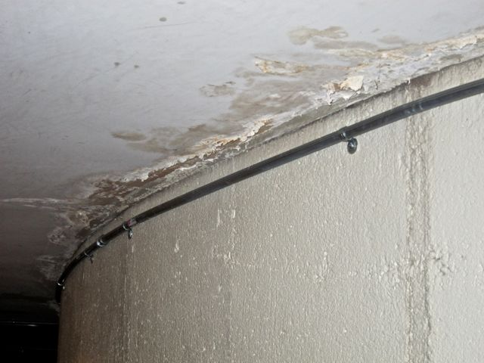

Photo # 6 – Austin Meehan M.S. – 8/13/14 – Ground Floor Hallway Across from Gym & School Store

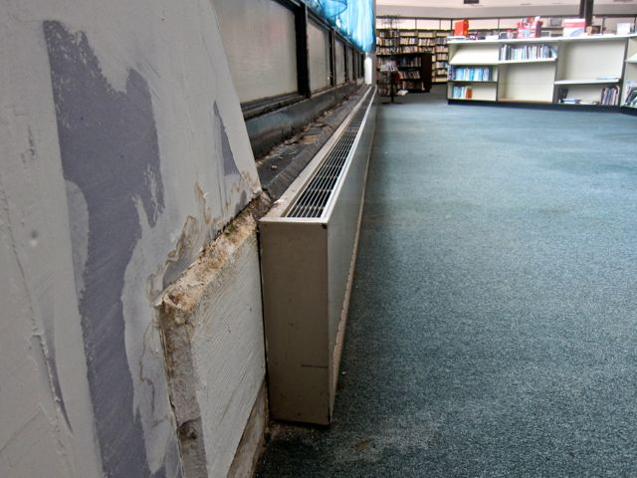

Photo # 7 – Austin Meehan M.S. – 8/13/14 – Library – Damage to/from and along Windows and to Carpet

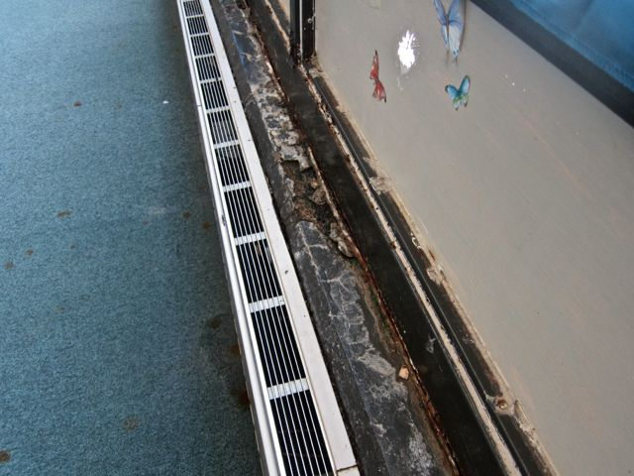

Photo # 8 – Austin Meehan M.S. – 8/13/14 – Library – Damage to/from and along Windows and to Carpet – Close-Up

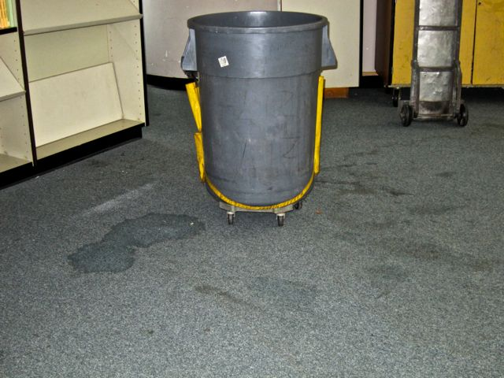

Photo # 9 – Austin Meehan M.S. – 8/13/14 – Library – Damage to/from and along Windows and to Carpet – wet for days/weeks – Carpet should be discarded

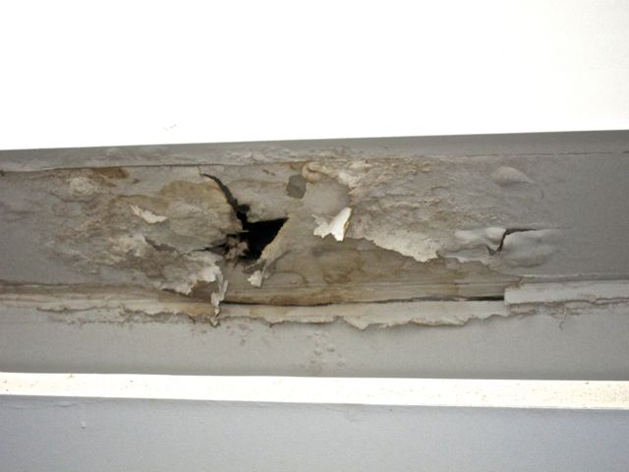

Photo # 10 – Austin Meehan M.S. – 8/13/14 – Library – Damage to drywall ceiling underneath “upper” windows

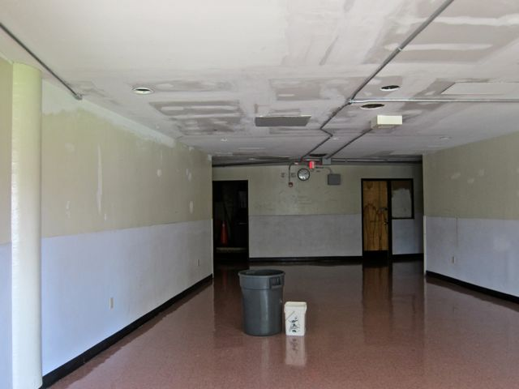

Photo # 11 – Austin Meehan M.S. – 8/13/14 – Auditorium Lobby – Ongoing water leak in previously “repaired” location

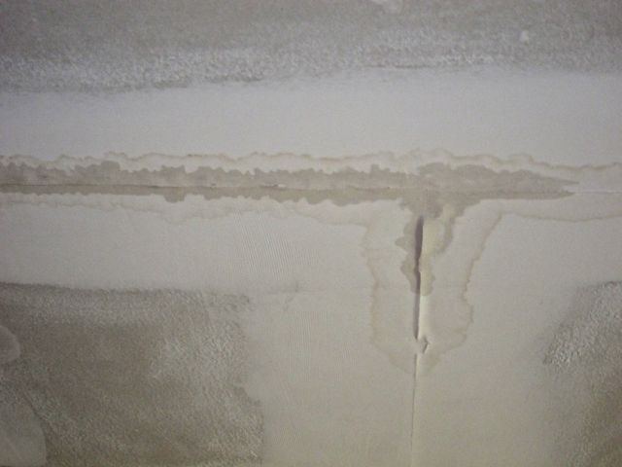

Photo # 12 – Austin Meehan M.S. – 8/13/14 – Auditorium Lobby -- Ongoing Water leak [Close-Up] – Area currently wet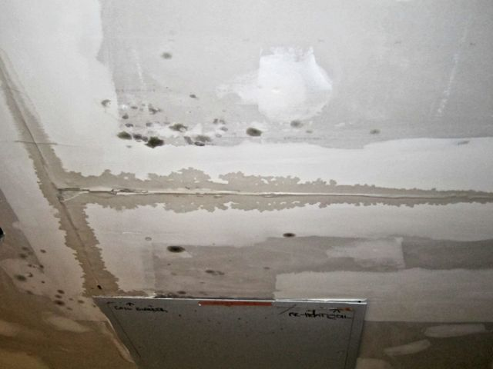

Photo # 13 – Austin Meehan M.S. – 8/13/14 – Auditorium Lobby Area [Leading to Main Entrance] – Mold growth observed